|  |  |  |
| --- | --- | --- |
| Assignment 4 | | |
| Using PCA method for Extracting Features from an Image Datasets | | |
| Student Name: saja eid aldosary | Section No: | Student ID :442050483 |

## In tutorials no 4 point 4.5 Principal Component Analysis, conduct the tutorial by finding suitable images from the internet.

## Or the internet to apply PCA to extract the same features (Two components).

%matplotlib inline

import matplotlib.pyplot as plt

import matplotlib.image as mpimg

import numpy as np

numImages = 16

fig = plt.figure(figsize=(7,7))

imgData = np.zeros(shape=(numImages,36963))

for i in range(1,numImages+1):

 filename = 'pics/Picture/'+str(i)+'.jpg'

 img = mpimg.imread(filename)

 ax = fig.add_subplot(4,4,i)

 plt.imshow(img)

 plt.axis('off')

 ax.set_title(str(i))

imgData[i-1] = np.array(img.flatten()).reshape(1,img.shape[0]*img

.shape[1]*img.shape[2])

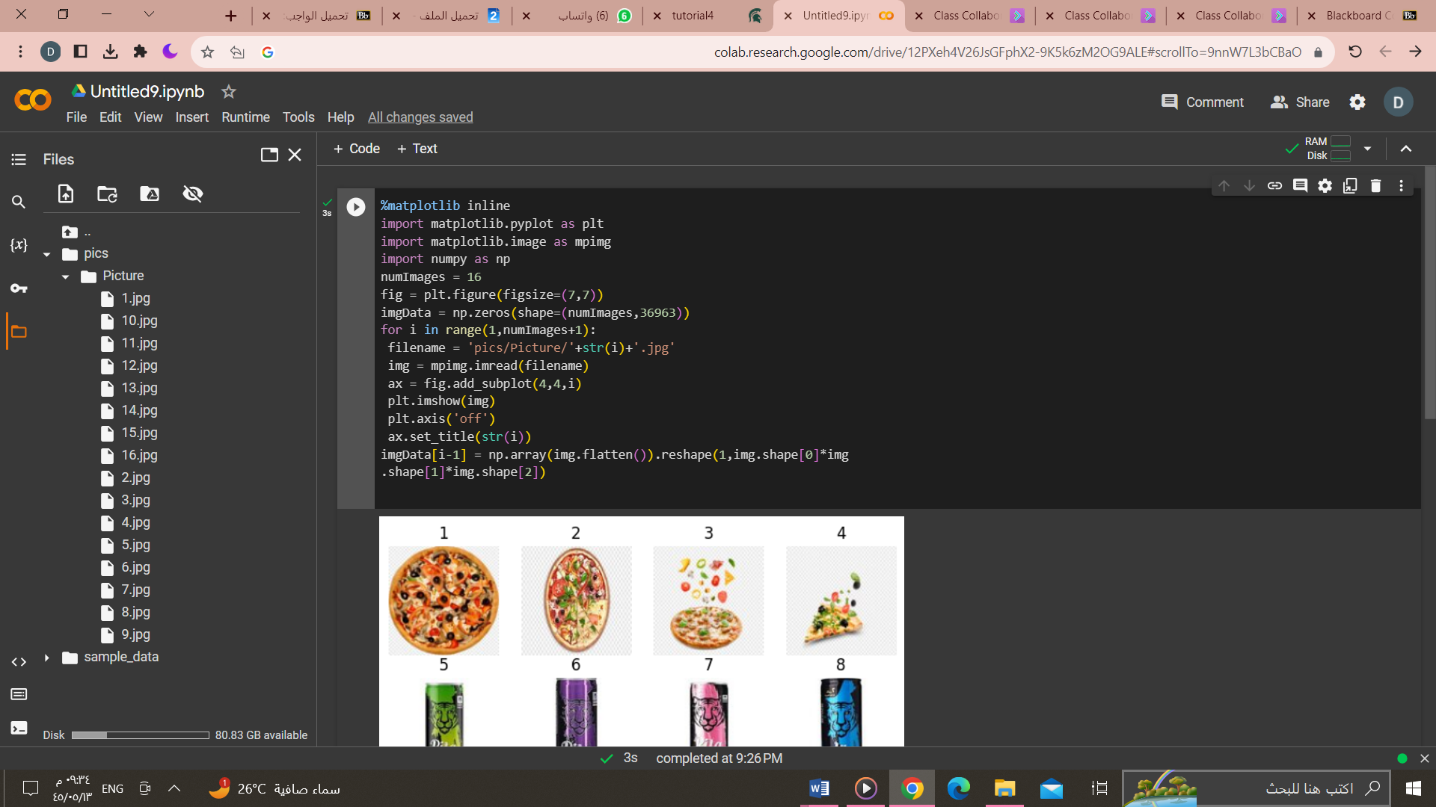

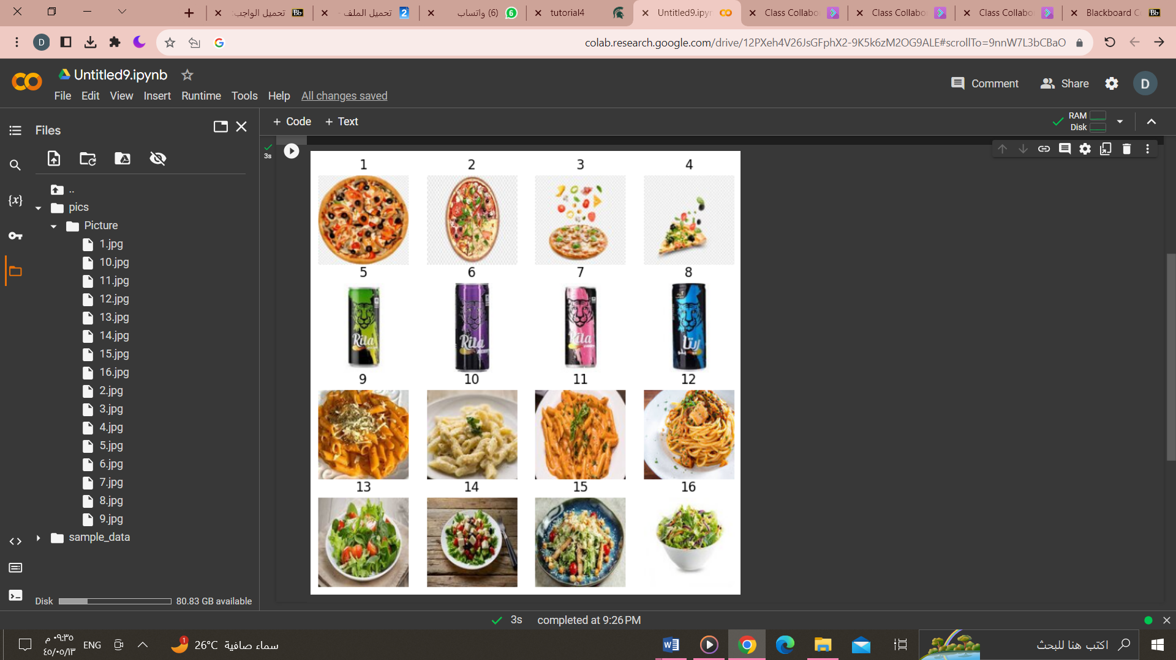

import pandas as pd

from sklearn.decomposition import PCA

numComponents = 2

pca = PCA(n_components=numComponents)

pca.fit(imgData)

projected = pca.transform(imgData)

projected = pd.DataFrame(projected,columns=['pc1','pc2'],index=range(1,numImages+1))

projected['food'] = ['pizza', 'pizza','pizza','pizza','drink','drink','drink','drink',

                      'pasta', 'pasta', 'pasta', 'pasta', 'salad', 'salad', 'salad', 'salad']

projected

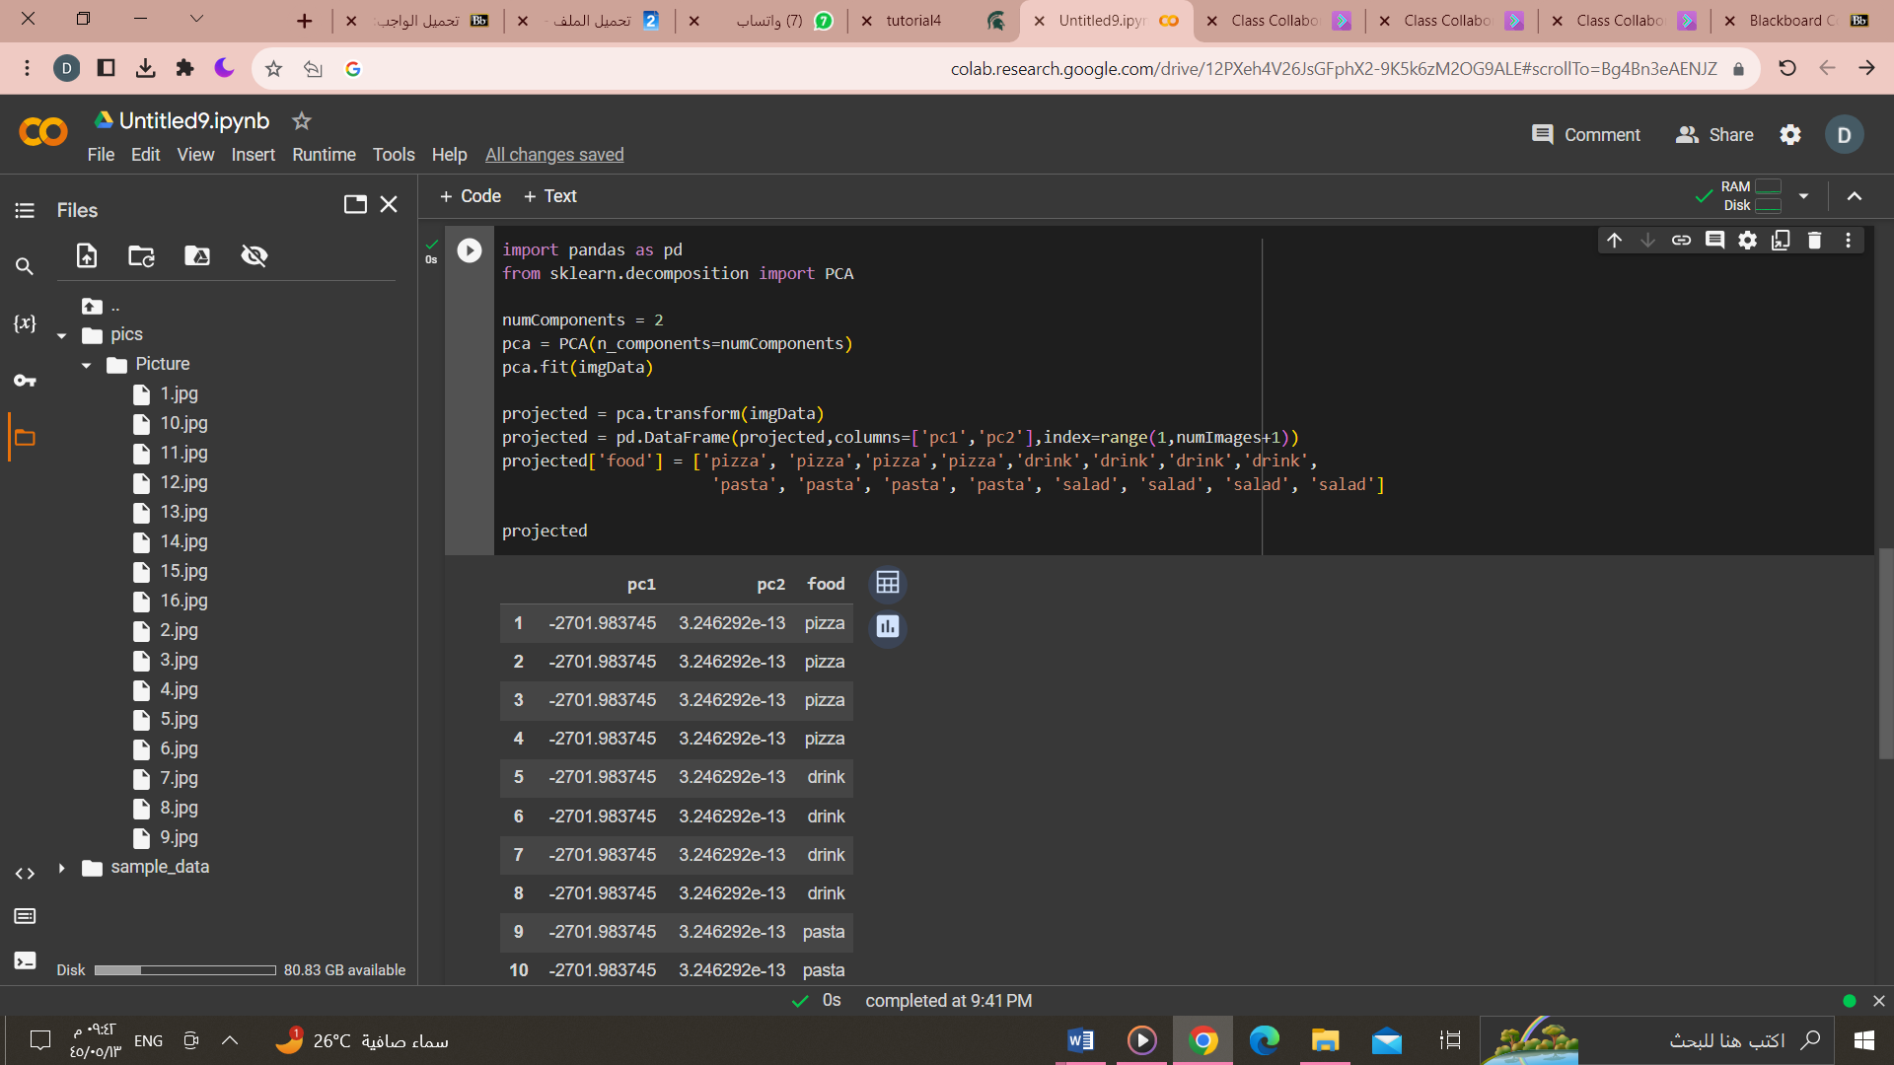

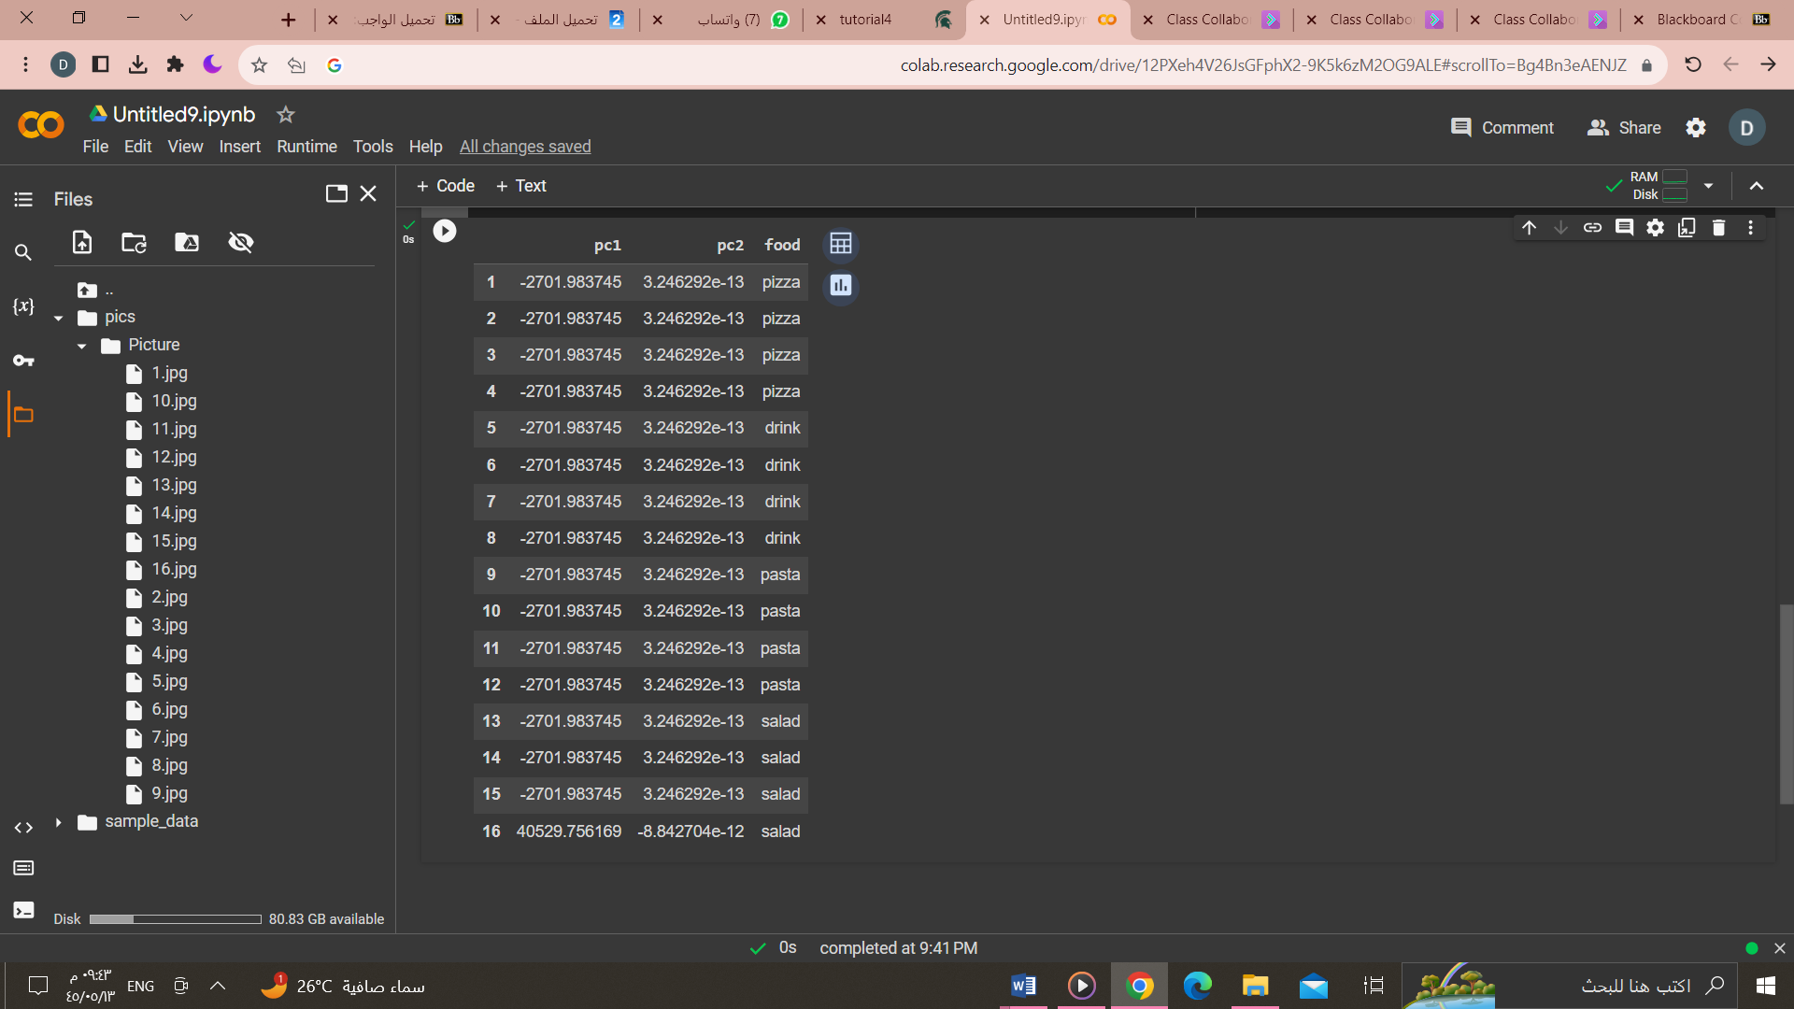

import matplotlib.pyplot as plt

colors = {'pizza':'b', 'drink':'r', 'pasta':'g', 'salad':'y'}

markerTypes = {'pizza':'+', 'drink':'x', 'pasta':'o', 'salad':'s'}

for foodType in markerTypes:

    d = projected[projected['food']==foodType]

    plt.scatter(d['pc1'],d['pc2'],c=colors[foodType],s=60,marker=markerTypes[foodType])

